Group:

Sean Poston

Mike Perry

Nate Halter

Academic Hall Outline

1. **Topic:** Academic Hall
2. **General Purpose:** To inform an audience.
3. **Specific Purpose:** To inform our class about the history, significance, and timeline of Academic Hall.
4. **Thesis:** Academic Hall has stood as a beacon on a hill for over a century, enduring change and hardships, and has now become the forefront icon of Southeast Missouri State University.

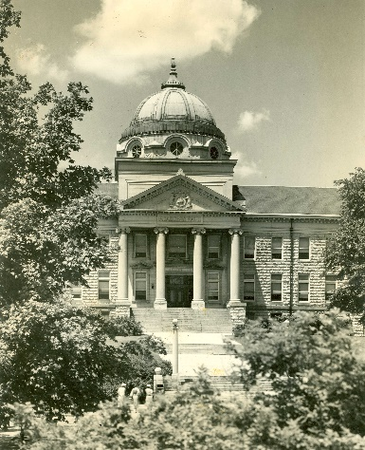**Attention Getter:** Picture of Academic Hall in the late 1930s.

1. Introduction
2. Academic hall has stood upon SEMOs hill for over a century. I want to tell you how it got there.
3. I remember in 2012 when the building was remodeled and received a refinishing on the copper dome. It always blinded me when I would drive to downtown in the afternoon. I went to the archives to search and read about the past of Academic Hall.

**Transition:** The original Academic Hall: The Normal School Building.

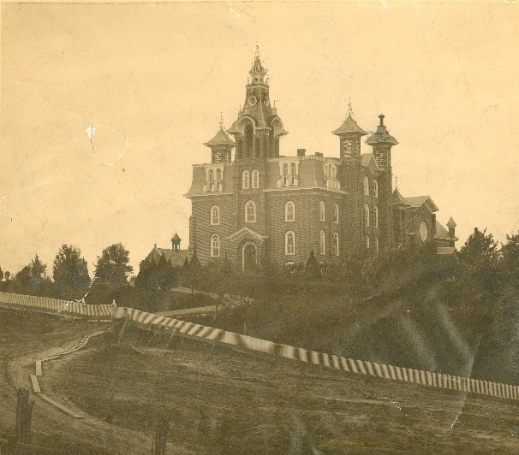

1. Body
2. The fire of the Normal School Building
   1. Burned down on the night of April 7, 1902 (University Grounds Collection).
   2. 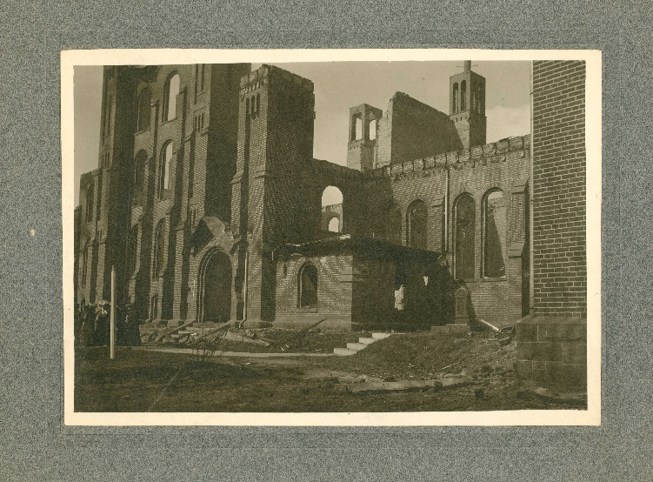The current Academic Hall was finished in 1906.
3. Uses of Academic Hall
   1. Library
      1. At Academic’s construction, “it provided students with a modern library” (Mattingly).
      2. 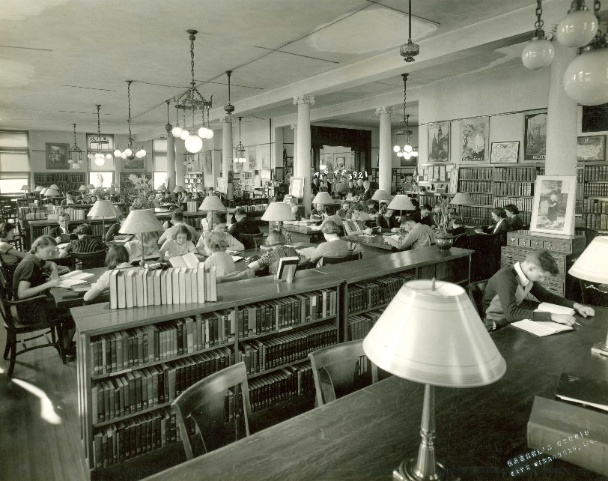There were over “4000 volumes… among these a history of the Civil War” (Mattingly).
   2. Proposed Dance Hall
      1. The students proposed that Academic be used for student dances (Mattingly).
      2. “After debating the issue, the faculty voted not to permit dancing at the Normal” (Mattingly).
4. Construction
   1. Dome
      1. The dome was originally sheathed in copper and refinished again in 2012 (University Grounds Collection).
      2. The Academic dome has been a characteristic for SEMO for many years and can even be seen on the front of SEMO’s Moodle page.

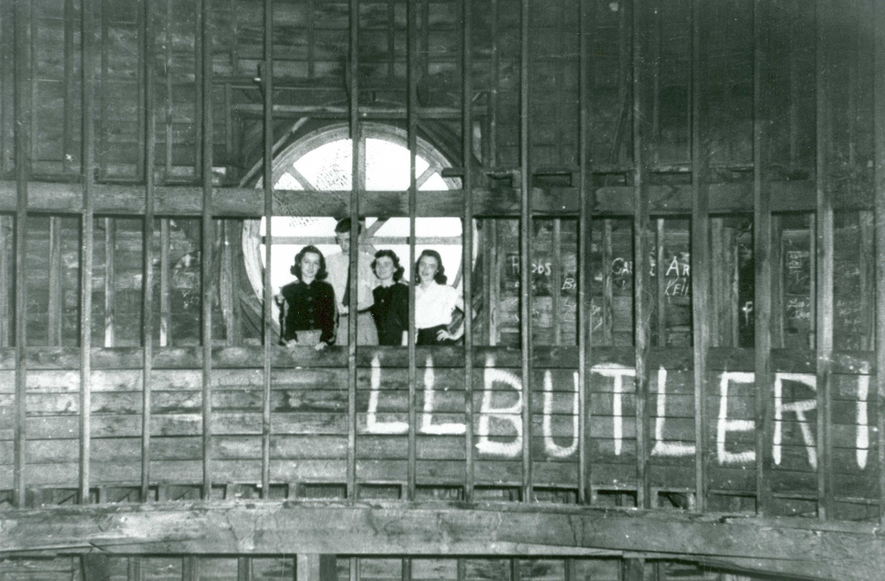

* 1. Symbolism
     1. The building was constructed out of limestone that was locally sourced, meaning the building’s roots are from Cape (University Grounds Collection).
     2. The dome was “topped with an acorn, representing the growth of higher education in Missouri” (University Grounds Collection).

1. Conclusion
2. **Summary:** Academic Hall was raised from the ashes of the Normal School Building. From there it housed the library and stood as a symbol for Southeast Missouri State University. It’s construction is reminiscent of the past of a Cape Girardeau that none of us knew, but is carried on in the building.
3. **Concluding Statement:** To conclude, Academic Hall was a symbol of hope after the Normal School Building burned down. It has since been remodeled and updated to continue its legacy of hope, where it will remain for another century (or until another fire or board decision). I hope you all enjoyed this presentation. Thank you.

Bibliography

Mattingly, Arthur H. “Normal To University: A Century of Service.” 1979. Missourian Litho and Printing Company. LoC: 79-67016.

<https://semo.contentdm.oclc.org/digital/collection/semophotos/id/98>

University Grounds Collection. <http://library.semo.edu/findingaids/University_Buildings_and_Grounds.pdf>.